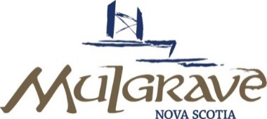
NOTICE

VIRTUAL MEETING: Meeting of the Mulgrave Town Council
MEETING LINK: Join Zoom Meeting: https://us02web.zoom.us/j/82962065321
See Bottom of page for call in options to join meeting
DATE: Monday, May 11, 2020
TIME/PLACE 6:30 PM -Mulgrave Education Centre-For Council Members Only
AGENDA
ITEM
1. |  | Call Meeting to Order
2. |  | Approval of Agenda / Addition of Items
3. |  | Minutes – April 16, 2020
4. |  | Reports /updates
 | a.  b.  c.  d.  e.  f.  g.  h.  i.  j.  k.  l. | Covid -19 update: office closure status  Capital Financing Wastewater Treatment Plant  -27% contribution requirement (111% of annual budget)  -Financing deadline  Financial Condition Indicators-Review of Response  Budget -Highlights of significant changes and capital list  Update: Staffing: Vacant positions  Update: Pirate Harbour paving  Update: Source water protection committee  Update: Donation from Medical Clinic/Food security grant  Update: Water plant sale  Update: New Wastewater Treatment Plant Project  Walking trail /ATV’s  Public Information Reminder -Heavy Garbage collection/hydrant flushing
5. |  | New Business / Correspondence /Info Item
 | a | Review of Provincial relief package for Municipal units (Covid -19)
6. |  | Approved Additions to the Agenda  -
7. |  | Date of Next Meeting- TBD. | -
8. |  | Gallery | -
9. |  | In-Camera  -Budget discussions including Labour contract, staff salaries, overtime reports  -Legal -Town Marina | -
10 |  | Adjournment | -
Call in options for meeting

Meeting ID: 829 6206 5321
One tap mobile
+17789072071,,82962065321# Canada
+14388097799,,82962065321# Canada

Dial by your location
+1 778 907 2071 Canada
+1 438 809 7799 Canada
+1 587 328 1099 Canada
+1 647 374 4685 Canada
+1 647 558 0588 Canada
Meeting ID: 829 6206 5321

Find your local number: https://us02web.zoom.us/u/kcAW8tIUPH

