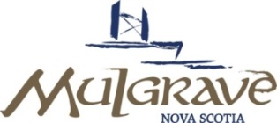
NOTICE

MEETING: Meeting of the Mulgrave Town Council
DATE: March 16, 2020
TIME: 6:30 PM
PLACE: Former Mulgrave Education Centre, Mulgrave, N.S.
AGENDA
ITEM
1. |  | Call Meeting to Order
2. |  | Approval of Agenda / Addition of Agenda Items
3. |  | Minutes – March 2, 2020
4. |  | Reports
 | a.  b.  c  d.  e. | Recreation report  Water report  Wastewater report  Public works report  Finance report
5. |  | New Business / Correspondence /Info Item
 | a.  b.  c. | Sale of old water plant  ESREN rebate of $939  Water account write offs.
6. |  | Approved Additions to the Agenda
7. |  | Date of Next Meeting- April 6/2020 (am- Amanda Ball /pm-council session)
8. |  | Gallery
9. |  | In-Camera  a. Legal update  b. Hiring
10 |  | Adjournment

