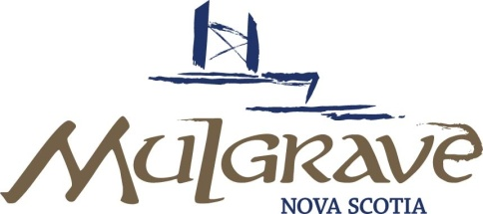
NOTICE

MEETING: Meeting of the Mulgrave Town Council
DATE: January 6, 2020
TIME: 6:30 PM
PLACE: Former Mulgrave Education Centre, Mulgrave, N.S.
AGENDA
ITEM
1. |  | Call Meeting to Order
2. |  | Approval of Agenda / Addition of Agenda Items | 1-2
3. |  | Minutes – December 16, 2019 | 3-4
4. |  | Reports
 | a | Guysborough Co Tourism Association  Ann Marie Bagnell, Nancy O’Regan, Stephen Flemming  i. Where at/Where going  ii. Governing Body (Council/ex officio members)  iii. County Logo/Slogan | Presentation
5. |  | New Business / Correspondence /Info Item
 | a.  b.  c.  d.  e.  g  h  k.  L.  M.  N.  o.  p.  q.  r.  s. | Pirate Harbour proposed windfarm  Invitation Cape Breton/Canso MP, Mike Kelloway  Aulds’Cove Intersection-Response  Returning Officer Employment Opportunity- Post with Feb 28 deadline  Central Square-Successful system update completed Dec 31/19  -Notice of rate increase by 5%  -Grid posting issue now resolved.  2020 Assessment roll received, Mail out by PVSC Jan 13, 2020  Mulgrave VFD-Accident Insurance renewed (Jan 2020-Jan 2021)  -Barrington Municipality-DOE & Early childhood Development  Credits to student VFD who join & take required training  -Request for Position update from department  Emergency response plan, Recovery & Continuity planning with school procedures.  WCB- Status report and rate change (1.70 to 1.82  Stats Canada Public Infrastructure Survey being completed  Lead Testing  Policing Act-Anticipated Charges (Municipal financial liability)  Keeping and Ryan properties : follow up  WWTP Contribution Agreement Amendment-allows for deadline extensions  NSFM Annual report-Emailed to counselors  ERSWM meeting-Dec 13th-Update from C’lr Broply | 5  6  7  8  Nil  Nil  Nil  Nil  9-10  11  -  -  Nil  12-13  Nil  14-15  16-18  Nil  19-20  Nil  Nil
6. |  | Approved Additions to the Agenda
7. |  | Date of Next Meeting- January 20th, 2020
8. |  | Gallery
9. |  | In-Camera  -Negotiations  -Staffing/Succession planning
10 |  | Adjournment

